**1 INTRODUCTION**

* 1. **Over view**

It provides a way for HR professionals and business leaders to track and analyze key performance indicators (KPIs) related to workforce planning, recruitment, retention, and development.

* 1. **Purpose**

It helps employers better understand the people they hire and retain by providing insight into their motivations and emotional responses to various workplace even bringing the data HR teams need together, safely providing stakeholders, access to trusted sources of truth, and exposing insights with intutive, powerful.

**2 PROBLEM DEFINITION & DESIGN THINKING**

**2.1 Empathy map**

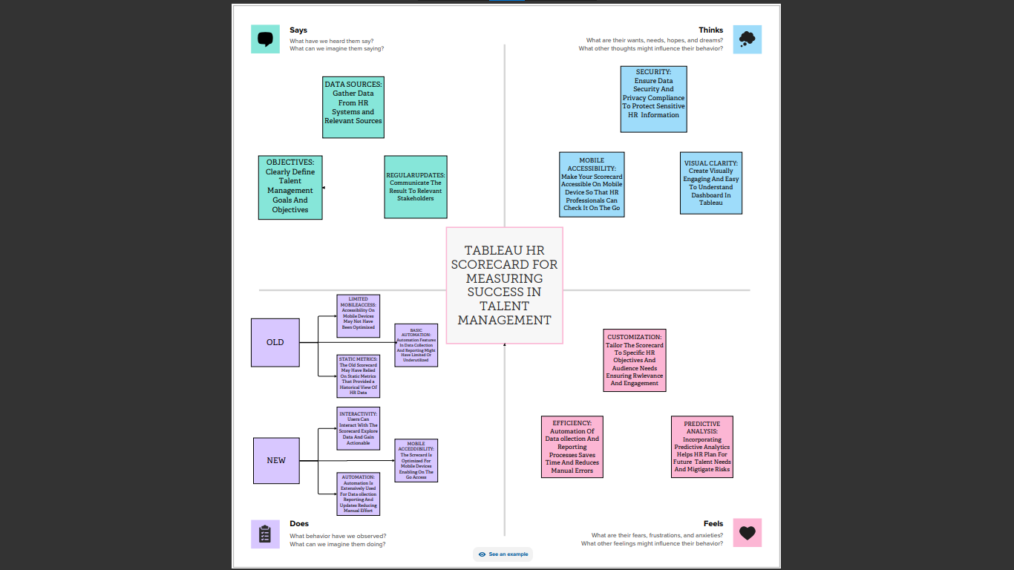

**2.2 IDEATION & BRAINSTORMING MAP**

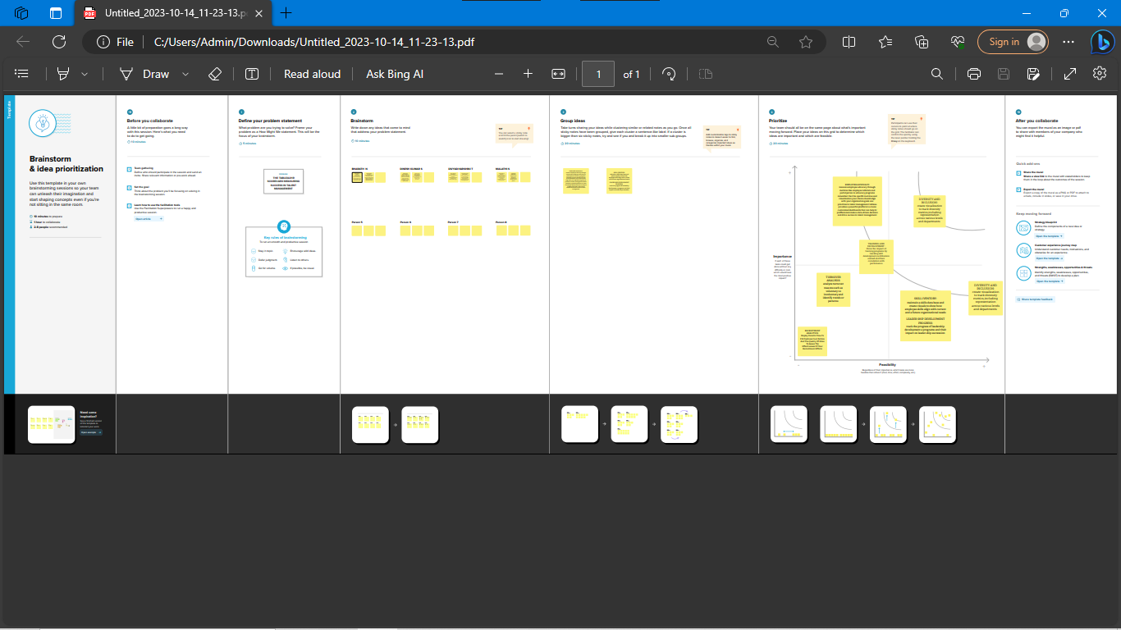

**3.RESULT**

It includes KPIs such as employee engagement, manager satisfaction with HR support, and candidate experience



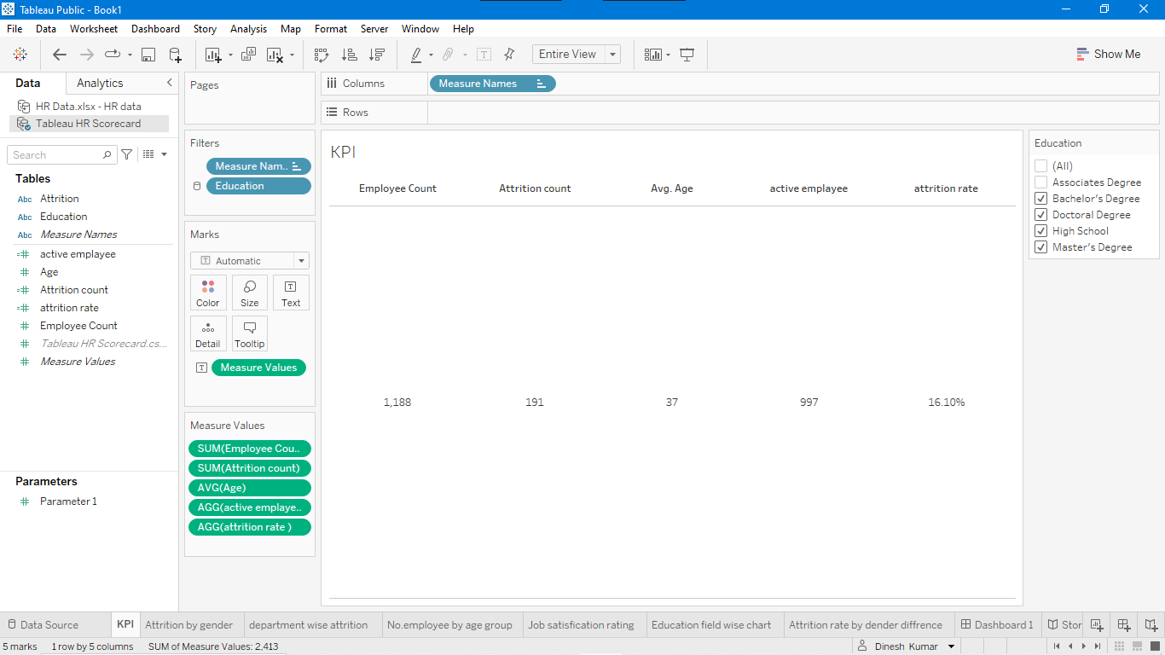

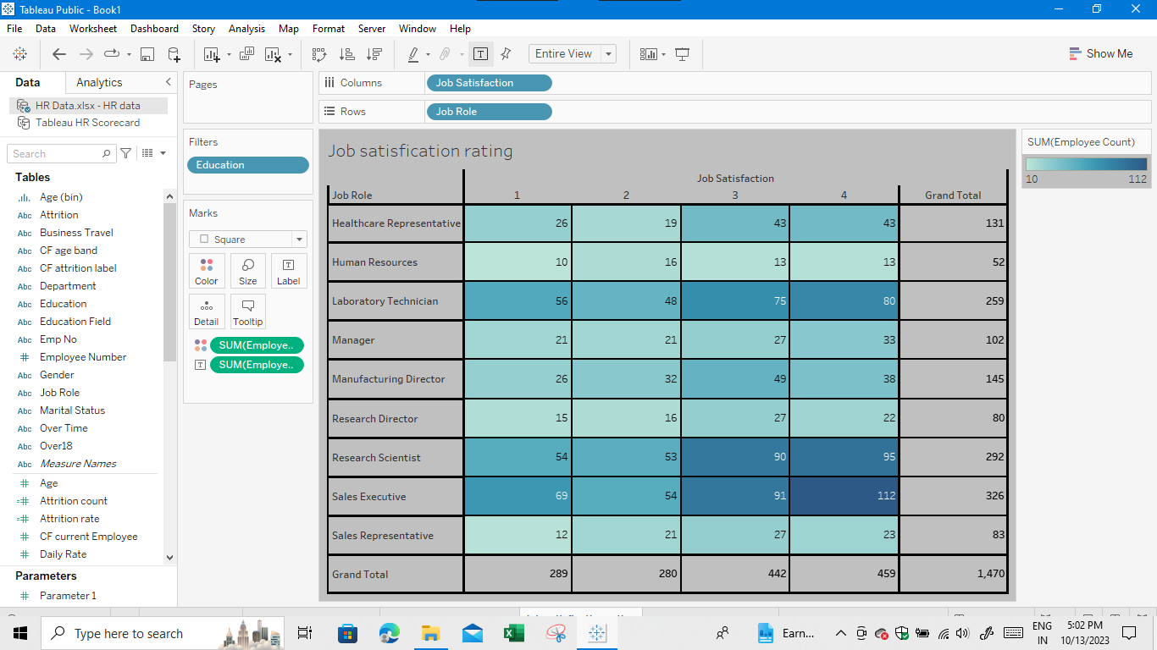

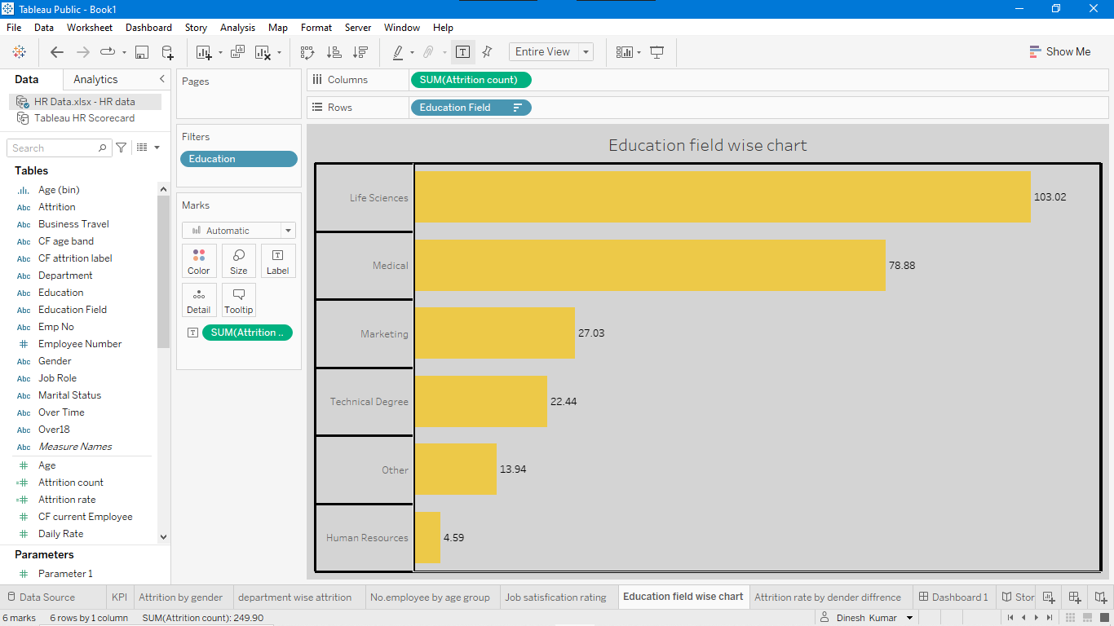

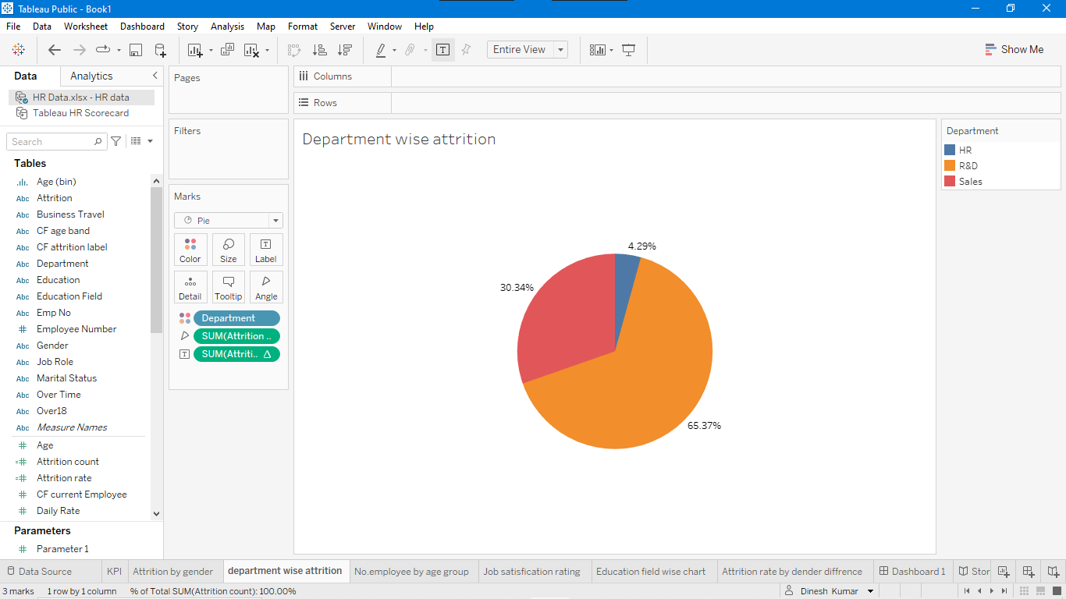

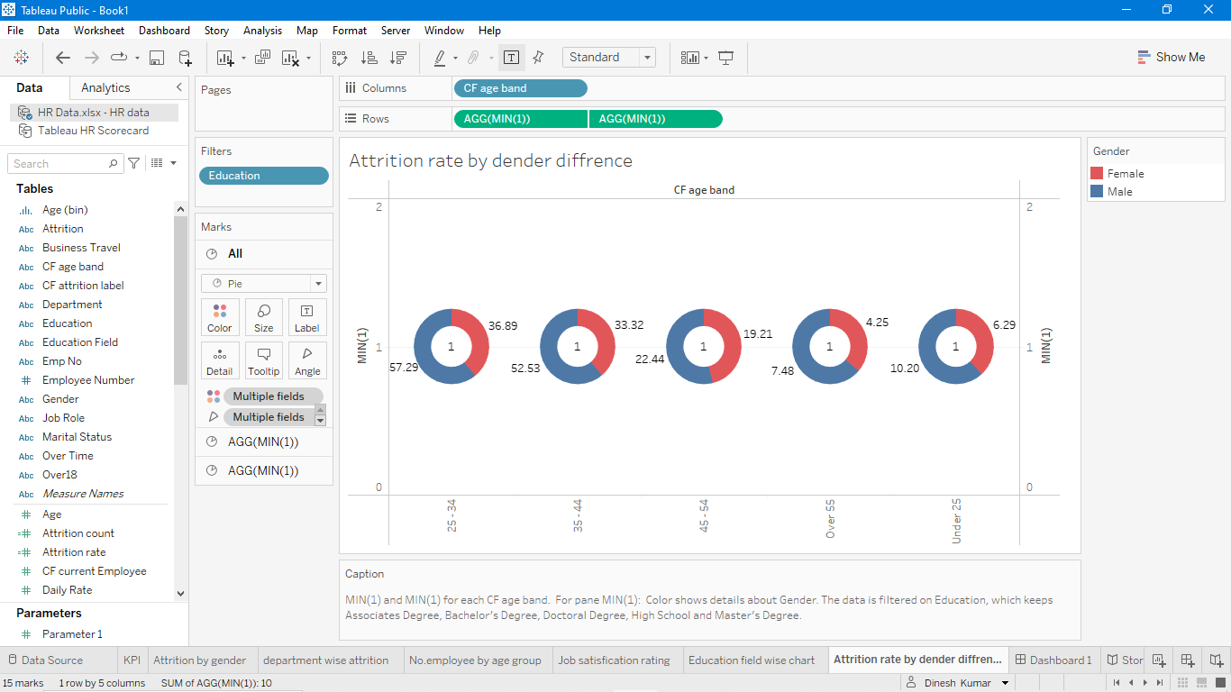

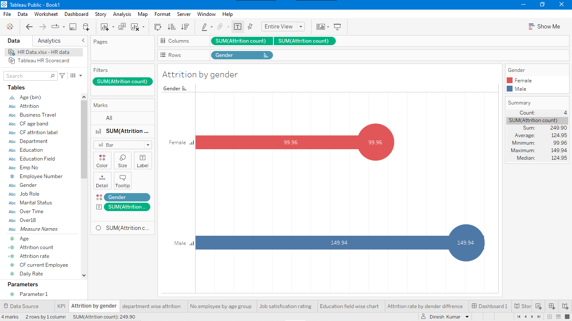

**4 ADVANTAGES & DISADVANTAGES**

**Advantages**

Human Resource Management helps in estimating the right number of people required for carrying out the necessary activities. It handle disputes and resolves all queries of workforce from time to time.

**Disadvantages**

Human Resource Management system require huge costs for installation within in business organization. Owners need to give proper training to its workers for getting up and running these systems.

**5 APPLICATIONS**

This perspective evaluates the organization investment in employee development and its ability to innovate and adapt to changing business needs. It includes KPIs such as employee skills and competencies, employee retention, and the percentage of employees who receive regular training and development.

**6 CONCLUSIONS**

The Human Resource Management play a important role in the daily life. On the hand hard and soft HR management are developed rapidly. It can improve employees and motivation in a business and get higher profits

**7 FUTURE SCOPE**

Balanced scorecards provide a holistic view of an organization site, program department, team or employee performance. HR will always have a scope in future because it is a field that is constantly changing. HR in the future will be a combination of technology and people analytics. It is a very dynamic field and one should never worry about scope in HR in near future